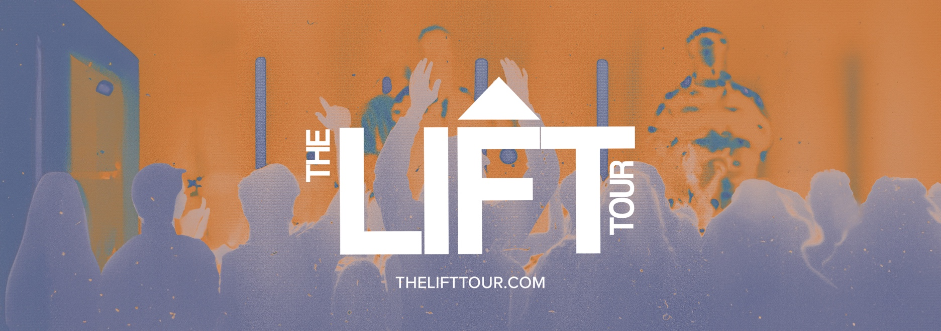

THE LIFT TOUR
Murfreesboro, TN // February 2-3, 2024

Welcome to the INVERSE!
We are so excited that you and your student(s) are interested in attending The LIFT Tour in Murfreesboro, TN!

While this specific event is for a private network and is a closed event, The LIFT Tour will be in Chattanooga, TN on March 1-2, 2024. We would love to see you there!

Click this link to register for The LIFT Tour in Chattanooga, TN or copy and paste https://slulead.com/lift-tours/chattanooga-tn/.

Please let us know if you have any questions or if we can help you in any way by emailing lifttour@studentleadership.net.

